Setup Grid and parallel execution

**Problem Statement:**

To understand selenium Grid setup and parallel execution of automation suite

**Steps to execute:**

1) Do the grid setup

2) Start the standalone server as hub

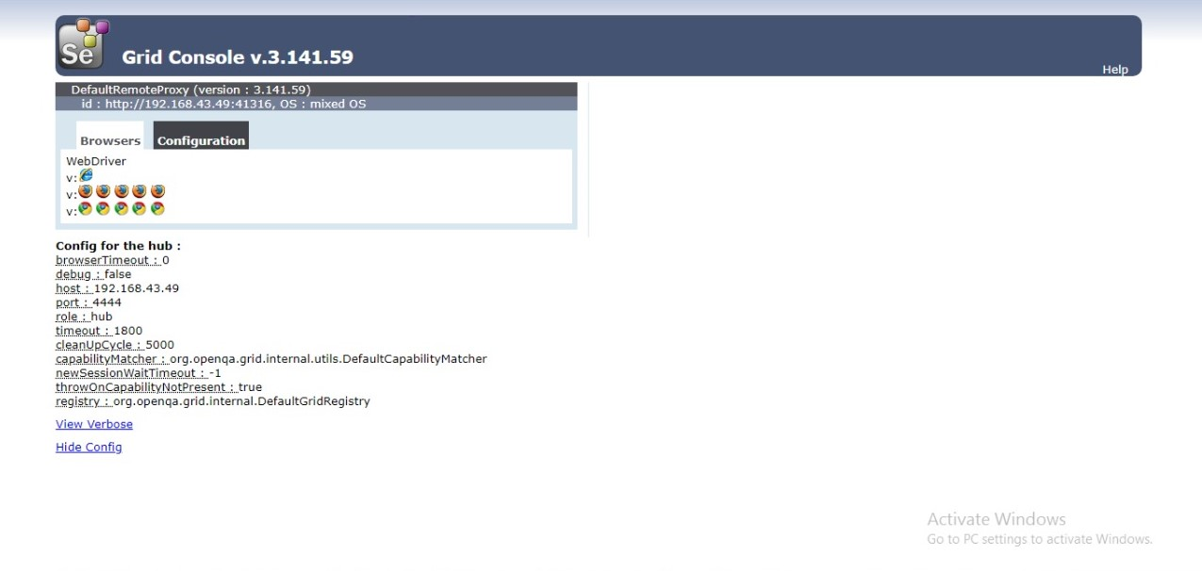

3) Start the node machines – use at least 5 machines

4) Update the Script code to be “fit” for grid execution

5) Use the default config and then show custom config – one or 2 parameters more than enough

java -jar selenium-server-standalone-2.44.0.jar -role hub

java -jar selenium-server-standalone-2.44.0.jar -role node -hub http://localhost:4444/grid/register

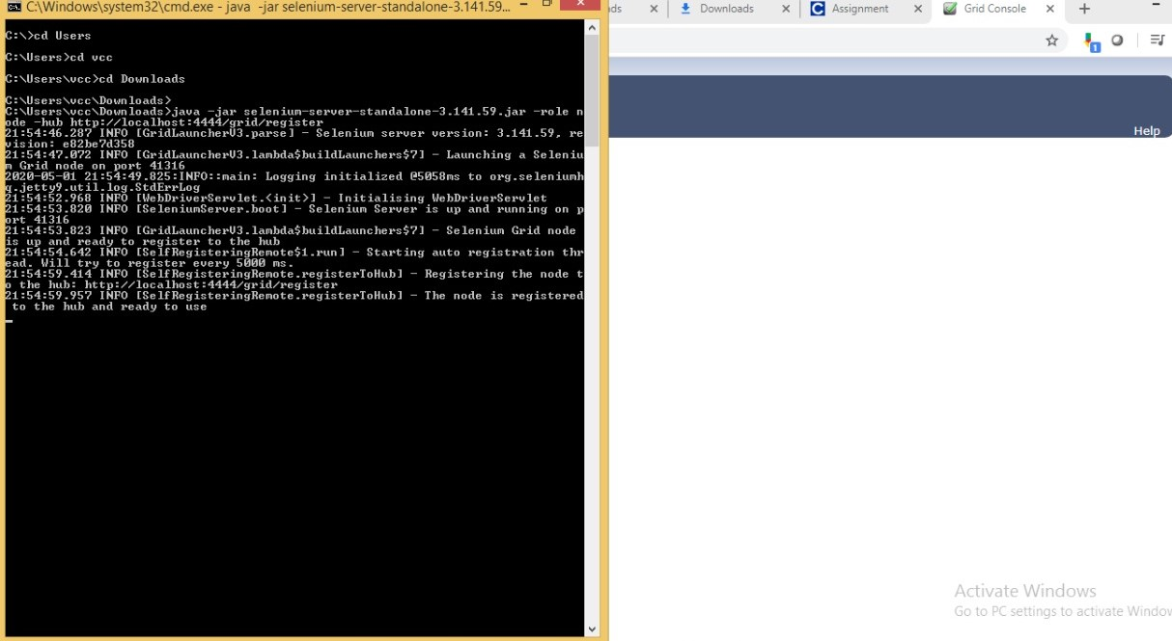

6) RemoteWebDriver instantiation rather than specific browser instantiation so that the grid can deploy test in any test exec machine.

7) Understand execution of 5 tests, note the duration, and linearly explore how much it will take for say 25 iterations.

**Note:**The tests can be any of their earlier developed scripts.

8) Now use the grid, and kick off the tests against the associate machines now acting as node machine.

9) Understand how grid is immensely helpful when 1000s of TCs have to be run within reasonable time window.

